**TASK 01:**

* Create an EC2 Instance:
  + AMI Linux
  + t2.micro - Instance Type
  + Enable Termination Protection
  + Security Group
    - Open it for:
      * SSH
      * HTTP
      * HTTPS
  + Tag:
    - Key
      * Name
    - Value
      * ProdInstance
  + Key Pair

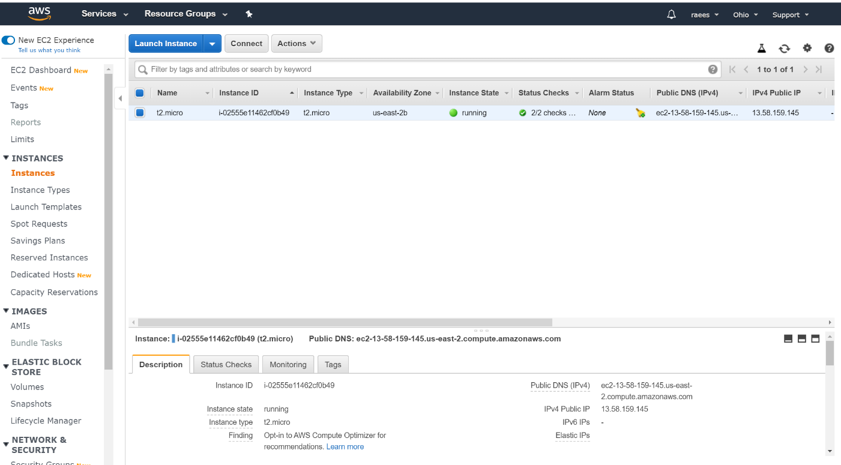

**TASK 02:**

* Connect with an instance using SSH on Windows using Putty

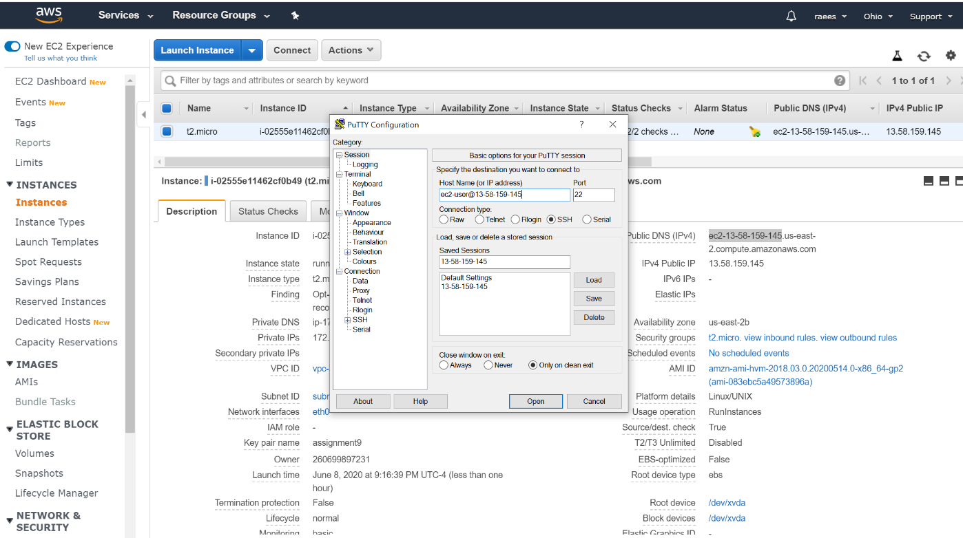

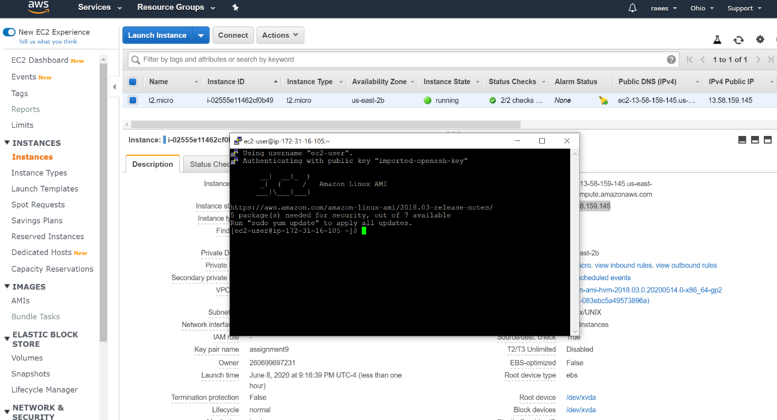

**TASK 03:**

* Install Apache Web Server

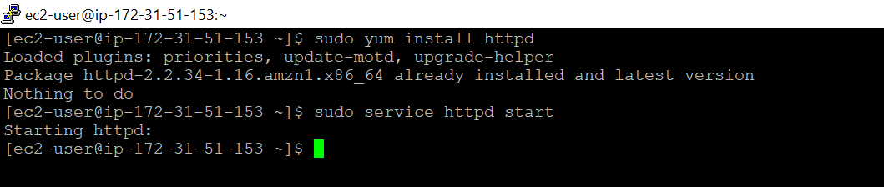

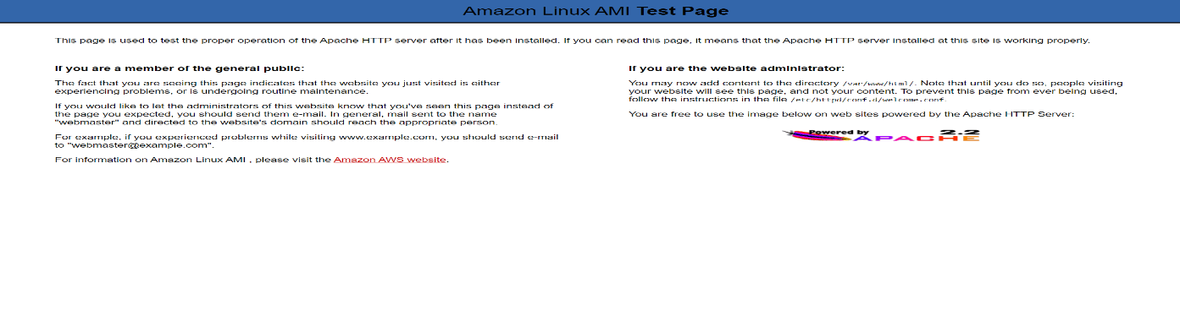Run the Public IP and see the output

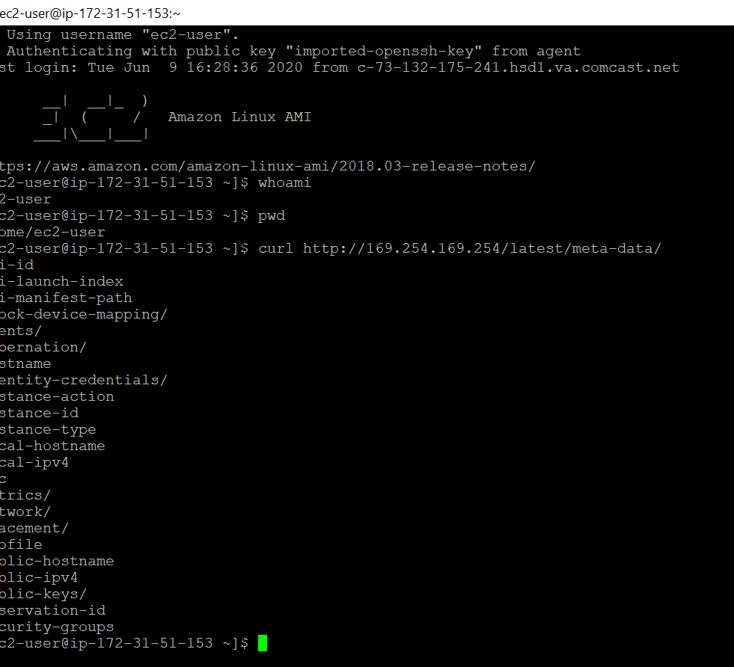

Create three more files in the same directory /var/www/html/

Home.html

payment.html

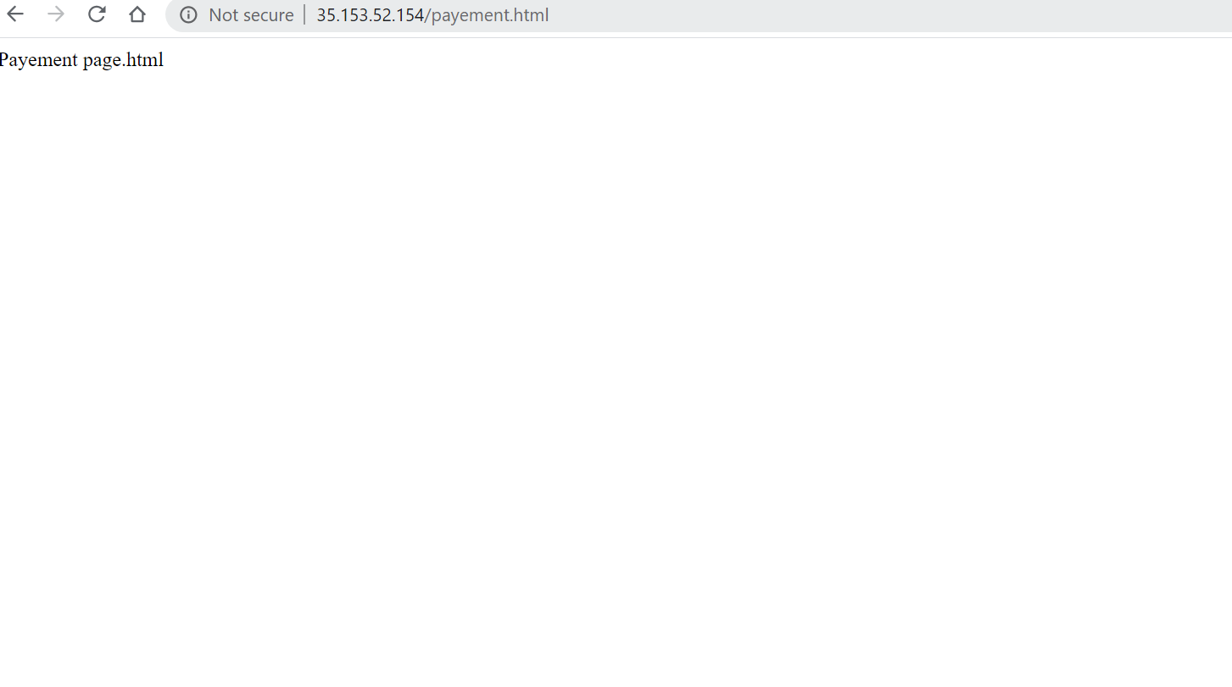

Login.html

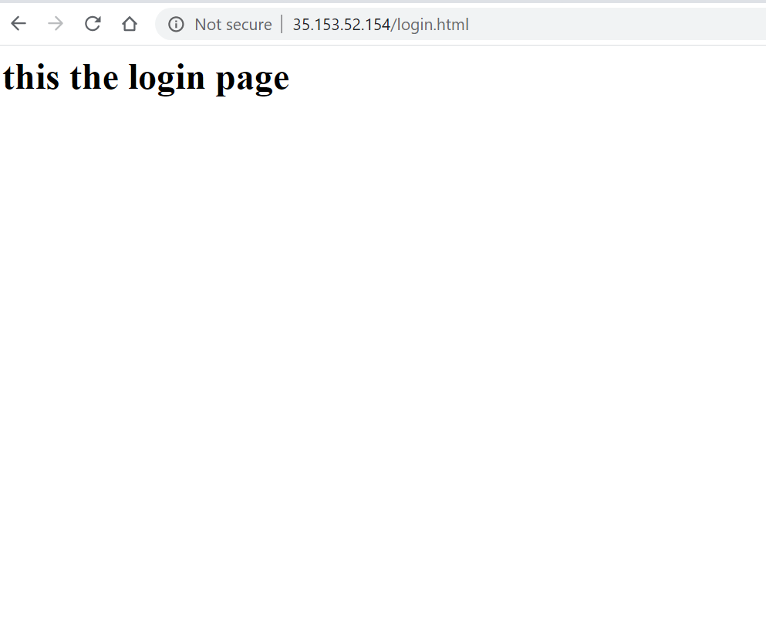

**TASK 04:**

Install Git on EC2 and Clone all your repositories separately on EC2 in the folder called “repoonec2”.

